Jetson Doorbell QuickStart Guide

# Introduction

I grew up watching the Jetson’s on TV in the 60’s and just loved the sound of their doorbell. I thought it would be fun to build an electronic doorbell that could play the Jetson’s tune and that is just what I did. However, it can play more than just the Jetson’s doorbell tune, it can play any WAVE file when the doorbell is rung. This means you can change how your doorbell sounds based on your mood, have Christmas tunes at Christmas time, scary sounds at Halloween, you name it.

The design has a simple web interface that allows you to upload new WAVE file tunes, play them, and adjust the volume. And, if there is ever a need for a firmware update, you can do that via the web interface as well.

WAVE files must be 16 bits per sample and 48KHz (preferred) or less sampling rate, and stereo or mono.

This design works with standard (in the US anyway) 16VAC to 24VAC doorbell systems (as long as 16VAC is present at the installation location) and requires Wi-Fi that you will need to configure.

# Box Contents

## Items included are:

1. Jetson Doorbell PCB
2. Illuminated Button Adapter PCB
3. Speaker cable
4. Welcome card with QR code that links to this file

## Items required but not included are:

1. Micro-SD card class U1 or higher
2. 4- or 8-ohm Speaker (note the speaker choice makes a big difference to the sound quality, I recommend at least a 4” speaker such as Visaton R 10 S)
3. Case for mounting everything (several example case designs are available in this repository that you can 3D print)
4. Wire and connectors as needed

# Setup

1. Prepare micro-SD card
   1. Make sure the micro-SD card is formatted FAT32 or exFAT
   2. Copy the following folders from this repository to the root of the SD card:  
      conf/, tunes/, and web_root/
2. Configure for your Wi-Fi by editing the following files:
   1. Edit the file ssid.txt to include the SSID of your wireless network
   2. Edit the file password.txt to include the password of your wireless network
   3. Optionally, edit the file hostname.txt to set the hostname as seen on your network, the default is “jetson”

# Typical Connections

Several typical connection scenarios are listed below. Find the one that closely matches your doorbell and connect the Jetson Doorbell as shown in the associated figure.

## Replace a single mechanical chime and non-illuminated button

Figure 1 Shows a typical circuit for a single mechanical doorbell.



Figure 1 Single Mechanical Doorbell

Figure 2 shows a circuit for replacing a single mechanical doorbell and a non-illuminated button with a Jetson Doorbell.



Figure 2 Jetson Doorbell with Non-Illuminated Button

## Replace a single mechanical chime and illuminated button

Figure 3 shows a circuit for replacing a single mechanical doorbell and an illuminated button with a Jetson Doorbell and the Illuminated Button Adapter.



Figure 3 Jetson Doorbell with an Illuminated Button

## Replace a single mechanical chime and video doorbell

Figure 4 shows a circuit for connecting a video doorbell to an existing single chime mechanical doorbell. Please note that some video doorbells require you to bypass the mechanical chime entirely and they provide the doorbell chime sound, and the Jetson Doorbell will not work with these configurations. For video doorbells that do work with existing mechanical chimes, there is typically a small device (labeled Chime Kit in the figure) that is connected in parallel with the chime (the Ring Wired Doorbell Pro calls this device Pro Power Kit). This device will need to remain connected between the BUTTON signal and 16VRTN signal.



Figure 4 Video Doorbell with Mechanical Chime

Figure 5 shows a circuit for replacing a single mechanical chime with a video doorbell and a Jetson Doorbell.



Figure 5 Jetson Doorbell with Video Doorbell

## Replace one of dual mechanical chimes

Figure 6 shows a setup with 2 mechanical chimes, perhaps one on the main floor and another on a 2nd floor or in a basement. When replacing just one of these mechanical chimes with a Jetson Doorbell, you should not need to use an Illuminated Button Adapter no matter if you have an illuminated button or not. The 2nd mechanical chime will perform the function of the Illuminated Button Adapter.



Figure 6 Setup with Dual Mechanical Chimes

Figure 7 shows a circuit after one mechanical chime has been replaced with a Jetson Doorbell. Again, note that this same configuration can be used with an Illuminated Button.



Figure 7 Jetson Doorbell Circuit with Remote Mechanical Chime

# Uploading New Doorbell Tunes

Assuming your Wi-Fi is configured correctly, you access the web interface of the Jetson Doorbell by entering [http://jetson](http://jetson/) in your browser. Note, if you chose to provide a different hostname by editing the hostname.txt file, enter [http://newhostname](http://newhostname/) in your browser. You should be greeted with a page that looks something like:

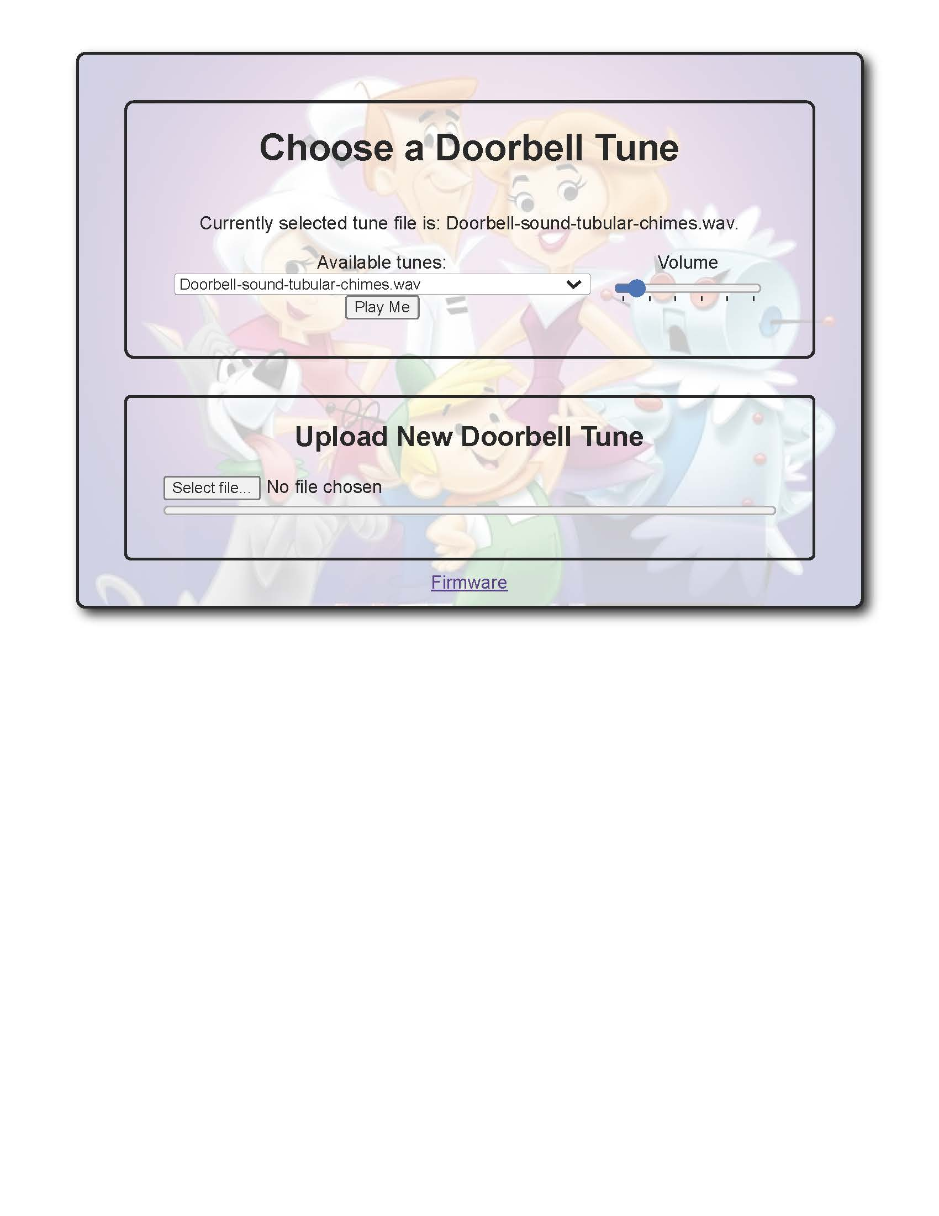The Available tunes: drop-down list will contain all the tunes presently in the SD card’s tunes/ folder. A few tunes have been provided to start with. Many more tunes can be found on the internet, a couple good places to start looking are [www.zapsplat.com](http://www.zapsplat.com/) and [orangefreesounds.com](http://orangefreesounds.com/).

Many sounds are available in other than WAVE formats such as MP3, but to use them they must be converted to WAVE format. My favorite way to convert these files to WAVE is using the free application [Audacity](https://www.audacityteam.org/), but there are also online converters that work as well.

Once you have a WAVE file to upload, just hit Select file… button and navigate to where your file is stored and select it. Once uploaded, it should now appear in the drop down list Available tunes:. You can test how it sounds by pushing the Play Me button and you can set the desired Volume using the slider.

# Updating your Doorbell

## Firmware Updates

As newer firmware is released you can update the Jetson Doorbell via the web interface. Follow the link at the bottom of the main web page named Firmware. You should be brought to a screen similar to the following:

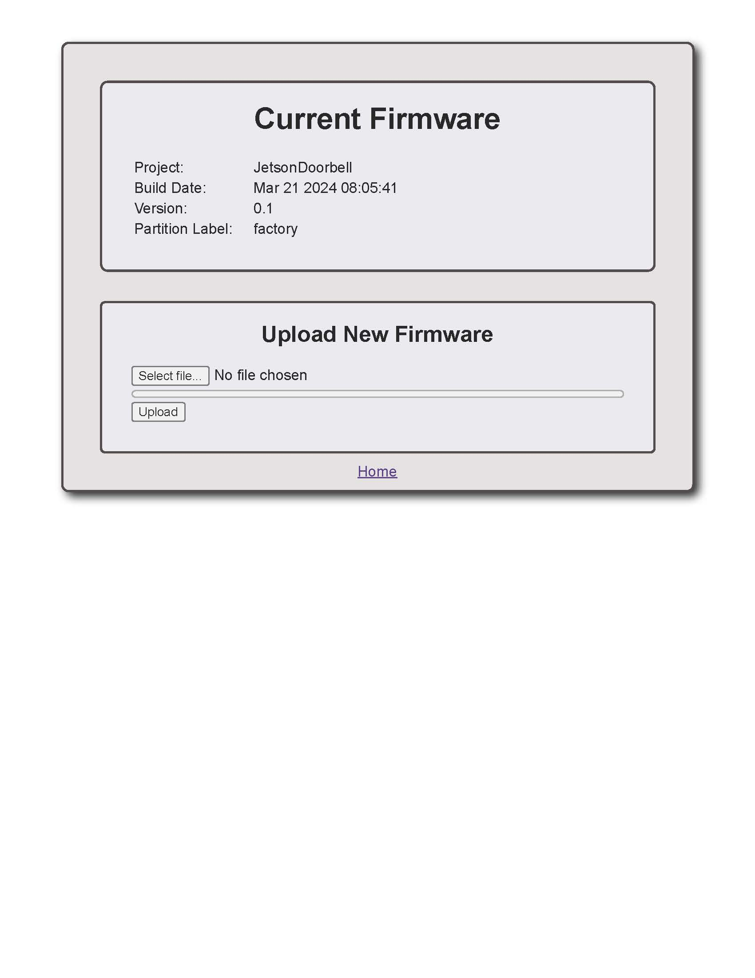

Simply push Select file… and navigate to the new firmware image, distributed in .bin format, and upload it. Depending on whether the firmware has been updated in the past, or how many times the partition label will change. There are 2 partitions (0 and 1) reserved for over the air updates and future updates will first go into partition 0, then 1, then 0, etc.

## Web Interface Updates

Any web interface updates are done by replacing the web_root/ folder on the micro-SD card with a new web_root/ folder. You will need to remove the micro SD card from the Jetson Doorbell and replace the files on your PC.

# Troubleshooting

## Error Detection

To help identify issues when things aren’t working, an error LED will blink a code. The LED will blink on/off at a 1 second rate a number of times representing the code of the error, and this then repeats after a 3 second delay.

Presently there are the following error codes identified:

* If there is no micro-SD card inserted or it is unreadable, the LED blinks error code 1.
* If any of the files contained in the conf/ folder cannot be read (except the optional hostname.txt file), the LED blinks error code 2.
* If the WiFi cannot be initialized, the LED blinks error code 3. The most common reason for this is the SSID (specified in ssid.txt file) or the password (specified in password.txt file) is not correct.

## Cannot find [http://jetson](http://jetson/)

If after booting, no error conditions exist, but you still cannot find the Jetson Doorbell by entering [http://jetson](http://jetson/) in your browser, your router may not be registering the name of the device. You can look at the DHCP leases that your router has issued to see if you can see the IP address that was issued by your router.

You can connect to the USB debug port to view a stream of messages from the Jetson Doorbell as it boots up. Connect the USB cable to your PC and use a serial terminal program such as [Putty](https://www.putty.org/) to view the message. Set the baud rate to 115200 with 8 data bits and no stop bit. One of the last messages after it boots lists “IP ADDRESS:xxx.xxx.xxx.xxx” if it is connected properly. In addition you should see message “connected to SSID:<your SSID> password:<your password>”. If anything has gone wrong, there will be different messages that should describe the problem.